April 2008

No-one knows for certain how April got its name. The Romans called this month Aprilis, which may have come from aperire, a Latin word meaning "to open". The Anglo-Saxons named this month after their goddess of the dawn, Eostre.

Sign of the Month
Aries
21 March to 20 April
Aries is the first sign of the Zodiac and the strongest of all the signs. You are rulers and pioneers. You prefer to give orders rather than take them. You enjoy travelling and change. You are impulsive, enthusiastic, adventurous, and generous. You have a fantastic sense of humour but can be very selfish. You are romantic but give too much importance to a person's appearance rather than their personality. Your health is good because of your strong resistance to infection. Look for a job in television, radio, or the world of sport. You would also make a good dancer.
Aries celebrities
Warren Beatty; Diana Ross; Matthew Broderick; Eric Clapton; Julia Roberts; Eddie Murphy; Julie Christie; Omar Shariff; Leonard Nimoy (Spock); Keanu Reeves

http://www.3sixty5.com/

APRIL 1ST

April fool’s Day
Tuesday April 1st is April fool’s Day. On this day people like to play tricks on each other.
April 'Fool (noun)

1/ a trick that is traditionally played on sb on 1 April (called April Fool’s Day or
All Fools' Day)

2/ a person who has a trick played on them on April Fool’s Day

APRIL 7th
http://www.holidayinsights.com/other/nohouseworkday.htm
No Housework Day is your chance to do anything, except housework. Better still, have someone else do the chores for a day. Housework is a daily, seemingly endless and repetitive group of tasks. It often goes unrecognized and worst of all..... taken for granted. But, watch out! If the dishes aren't done, or there are no clean towels, somebody will take note.
There's two ways to celebrate this day:
If you normally do the housework around the house, cease and desist for this day. Instead, kick back and enjoy the day. Relax and do anything, except housework.

chores – 1/ a task that you do regularly, 2/ an unpleasant or boring task
seemingly - in a way that appears to be true but may in fact not be
unrecognized - that people are not aware of or do not realize is important
take st for granted - to be so used to sb/sth that you do not recognize their true value any more and do not show that you are grateful
watch out - used to warn sb about sth dangerous
take note - to notice or pay careful attention to sth
cease - to stop happening or existing; to stop sth from happening or existing
desist - to stop doing sth
kick back - to relax

APRIL 23rd
Who was St George?
St. George is the patron saint of England. His emblem, a red cross on a white background, is the flag of England, and part of the British flag. St George's emblem was adopted by Richard The Lion Heart and brought to England in the 12th century. The king's soldiers wore it on their tunics to avoid confusion in battle.
Like England, every country in the UK has its own patron saint who in times of great peril is called upon to help save the country from its enemies. Saint George is popularly identified with England and English ideals of honour, bravery and gallantry.
Who was the real St George and what did he do to become England's patron saint?
St George was a brave Roman soldier who protested against the Romans' torture of Christians and died for his beliefs.
Quick Facts about St George
- Born in Turkey (in Cappadocia)
- Lived in 3rd century
- His parents were Christian
- Became a Roman soldier
- Protested against Rome's persecution of Christians
- Imprisoned and tortured, but stayed true to his faith
- Beheaded at Lydda in Palestine
How does England celebrate St George's Day?
By tradition, April 23rd is the day for a red rose in the button hole, the national flower. However, unlike other countries, England does not celebrate it like Americans celebrate 4 July with fireworks. In fact, you are more likely to see big St Patrick parades in England celebrating Ireland's National Day, more than you would see any sign of St Georges Day being celebrated. This was certainly true in Manchester in 2003, when St George's Day was virtually ignored soon after the biggest St Patrick's Day Celebrations in the city's history.
For most people in England St George's Day is just another ordinary day.
The Legend of Saint George and the Dragon
The most famous legend of Saint George is of him slaying a dragon. In the Middle Ages the dragon was commonly used to represent the Devil. The slaying of the dragon by St George was first credited to him in the twelfth century, long after his death. It is therefore likely that the many stories connected with St George's name are fictitious.
There are many versions of story of St George slaying the dragon, but most agree on the following:
A town was terrorised by a dragon A young princess was offered to the dragon and when George heard about this he rode into the village, slayed the dragon and rescued the princess.
The Legend of St. George and the Dragon

St. George journeyed for many months by land and sea until he came to Libya. Here he met a poor hermit who told him that everyone in that land was in great distress, for a dragon had long ravaged the country.
'Every day,' said the old man, 'he demands the sacrifice of a beautiful maiden and now all the young girls have been killed. The King's daughter alone remains, and unless we can find a knight who can slay the dragon she will be sacrificed tomorrow. The king of Egypt will give his daughter in marriage to the champion who overcomes this terrible monster.'
When St. George heard this story, he was determined to try and save the princess, so he rested that night in the hermit's hut, and at daybreak set out to the valley where the dragon lived. When he drew near he saw a little procession of women, headed by a beautiful girl dressed in pure Arabian silk. The princess Sabra was being led by her attendants to the place of death. The knight spurred his horse and overtook the ladies. He comforted them with brave words and persuaded the princess to return to the palace. Then he entered the valley.
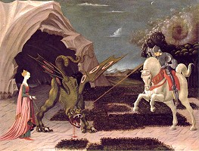
As soon as the dragon saw him it rushed from its cave, roaring with a sound louder than thunder. Its head was immense and its tail fifty feet long. But St. George was not afraid. He struck the monster with his spear, hoping he would wound it.

The dragon's scales were so hard that the spear broke into a thousand pieces. and St. George fell from his horse. Fortunately he rolled under an enchanted orange tree against which poison could not prevail, so that the venomous dragon was unable to hurt him. Within a few minutes he had recovered his strength and was able to fight again.
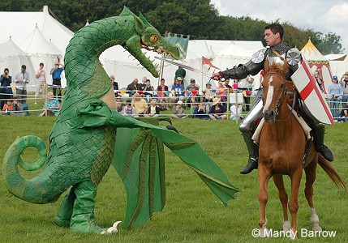
He smote the beast with his sword but the dragon poured poison on him and his armour split in two. Once more he refreshed himself from the orange tree and then, with his sword in his hand, he rushed at the dragon and pierced it under the wing where there were no scales, so that it fell dead at his feet.
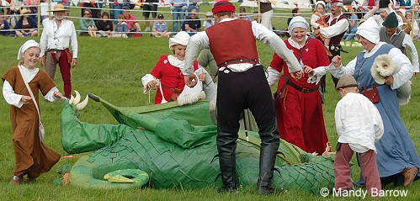
http://www.woodlands-junior.kent.sch.uk/customs/stgeorge.html
APRIL 22nd
Earth Day

The International Earth Day started as an environment movement demanding a healthy and sustainable environment in response to the pollution caused by industrial development in USA in the 1960s. Earth Day is now widely celebrated around the world as a collective expression of public will to create a sustainable society. Every year on 22 April, or the weekends before or after, many communities and groups organize week-long or month-long environmental activities.

Vocabulary:

in response to - a reaction to sth that has happened or been said
pollution - the process of making air, water, soil, etc. dirty; the state of being dirty
will- 1/ a feeling of strong determination to do sth that you want to do, 2/ what sb wants to happen in a particular situation

http://resources.kaboose.com/games/earthday.html
http://www.billybear4kids.com/holidays/earthday/games.htm
http://edition.cnn.com/EVENTS/1996/earth_day/kids.html

